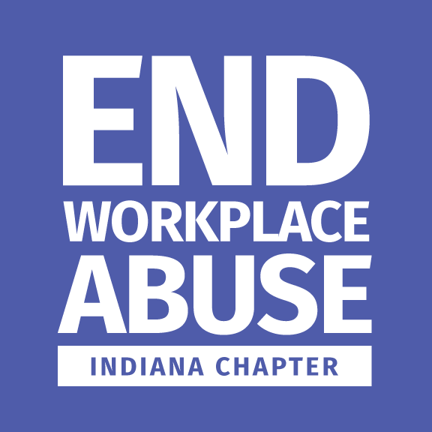


  - End Workplace Abuse – Indiana
(EWA-IN)
  - Workplace Pledge Partnership

  - SHOW YOUR COMMITMENT TO PSYCHOLOGICALLY SAFE WORKPLACES
Through the Workplace Psychological Safety Pledge, End Workplace Abuse aims to create strong workplace psychological safety laws to create psychologically safe workplaces. Policies that ensure psychologically safe workplaces for all Americans help businesses attract the strongest talent, boost productivity, and benefit our entire economy.
At the national and local levels, we are securing business commitments to workplace psychological safety and employee protections. Together, we are actively moving the needle forward to #EndWorkplaceAbuse.
We challenge businesses to take the Workplace Psychological Safety Pledge and commit to:
- Create an anti-bullying policy and train all company workers in it.
- Conduct an annual company-wide workplace climate survey.
- Investigate reports of workplace abuse.
- Enforce the anti-bullying policy through coaching, counseling, or discipline, including termination.
- Publicly share the numbers of workers’ compensation claims, absenteeism, stress leave, attrition rates, reports of discrimination and psychological abuse, workforce gender and racial makeup, and investigation and follow-up action rates.
- Support the Workplace Psychological Safety Act by writing legislators to ensure basic human rights for all workers.
Sign the pledge on the following link!
https://workplacepsychologicalsafetyact.org/take-the-pledge/
Sign here, letting EWA–IN know you signed the pledge!

___________________________________________________ ____________________________
Company Representative/Title Date

___________________________________________________
Company Name
Upon signature and verification, the EWA–IN will:
- Include your company/organization name/logo on the Indiana website (once created) as a Pledge Partner. (Your company will immediately be recognized nationally.)
- Recognize your company/organization as a Pledge Partner in media, print materials, and programs.
- Include your company/organization and/or representative in events taking place in Indiana.

